November 2015

Alan Loh - 胡子皓 - Fabien Lahaille

National Taiwan University

Assignment III Robot Vision

Robotics

Table of contents

Introduction 2

Part A : Camera calibration 3

I. Description of the camera 3

Camera used 3

II. Material provided 3

Printed checkerboard 3

III. Matlab 4

IV. Description of the intrinsic parameters 7

Bibliography 8

# Introduction

Robot vision is a subject leading various application in different fields such as electronic conceiving, medical or agribusiness, or security issues...

Nowadays, many industries use cameras implanted in machines so to develop the large capability of robots, the main idea is to increase productivity by automation.

In this way, the development of tracking moving objects allows to take information so to give command orders to different mechanical element in the supply chain management.

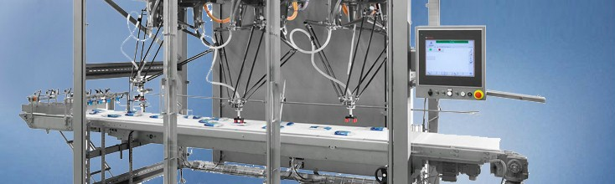

(Bosch ‘Pick and Place’ machine)

Then, the purpose of this assignment will introduce us to the concept of tracking object, using computer language such as OpenCV or Matlab and cameras technology.

# Part A : Camera calibration

This part is an introduction to the use of camera calibration, we have different tools to manipulate images information so to extract intrinsic parameters from a camera.

## Description of the camera

### Camera used



Cell phone : Asus Zenfone 2

Camera : 13MP (Rear) - F-2 lens

Max. Resolution provided : 4096 x 3072 (4:3)

Resolution used : 1080 x 1920 (16:9)

## Material provided

### Printed checkerboard

X

Y

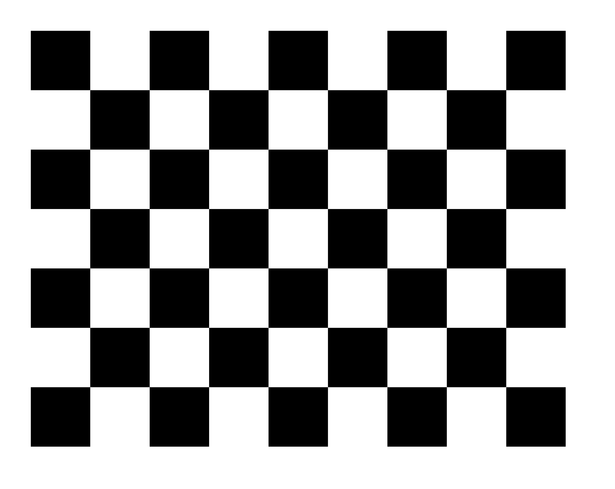

(Image of the checkboard to use)

Size dX of each square along the X direction ([ ] = ) = 28 mm

Size dY of each square along the Y direction ([ ] = ) = 28 mm

## Matlab

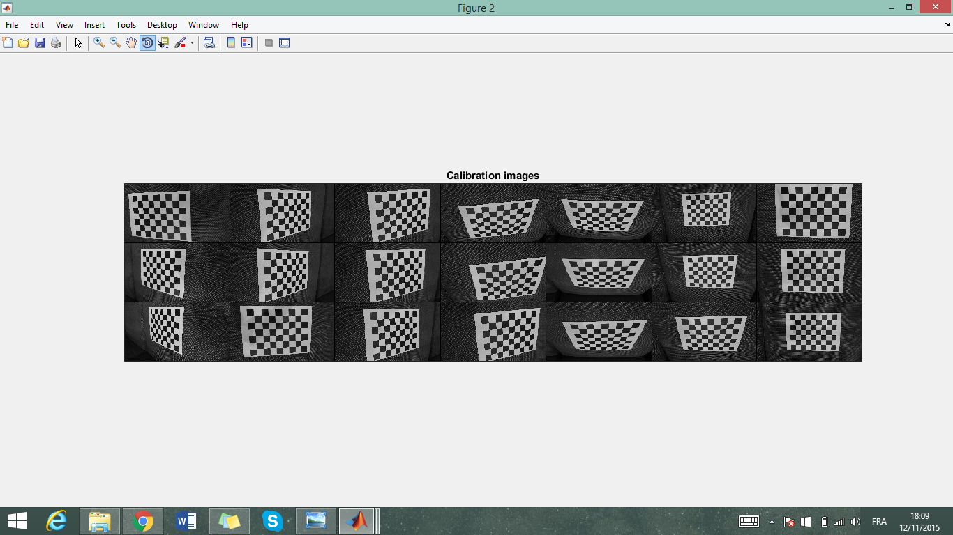

*(Set of photos captured)*

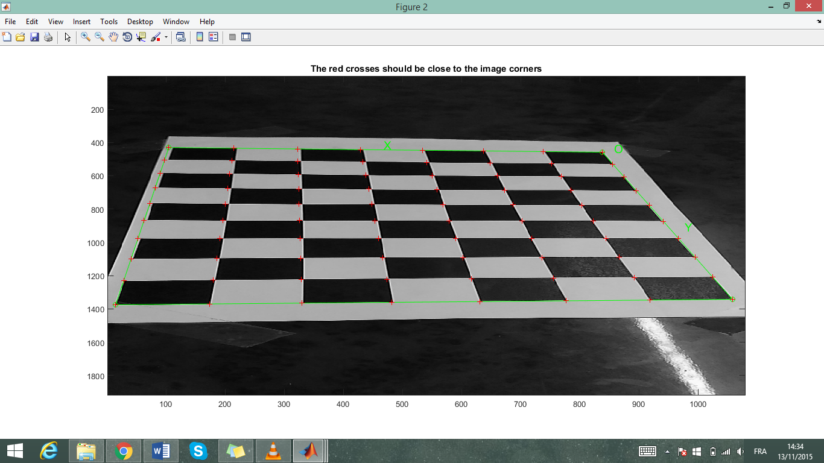

*(Corner extraction)*

After setting the different coordinates of the image and preset the real dimensions of the squares, we can get the corners connecting all the squares of the picture (represented as the red cross) so to calibrate our camera.

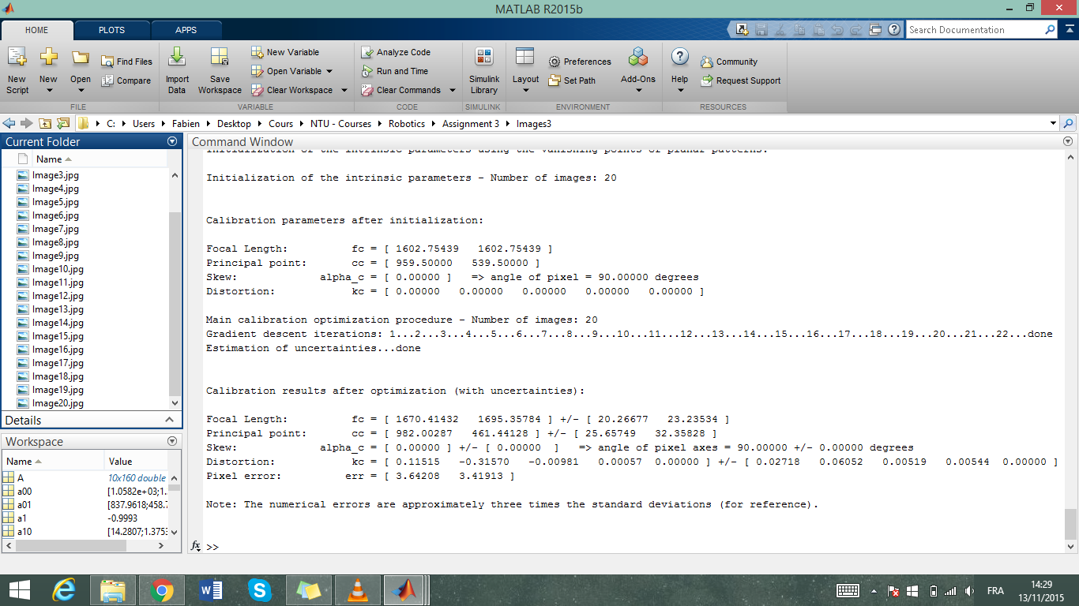

*(Values extracted after calibration)*

When can notice that the pixel error is relatively low so that relies the accuracy of the pointing phase.

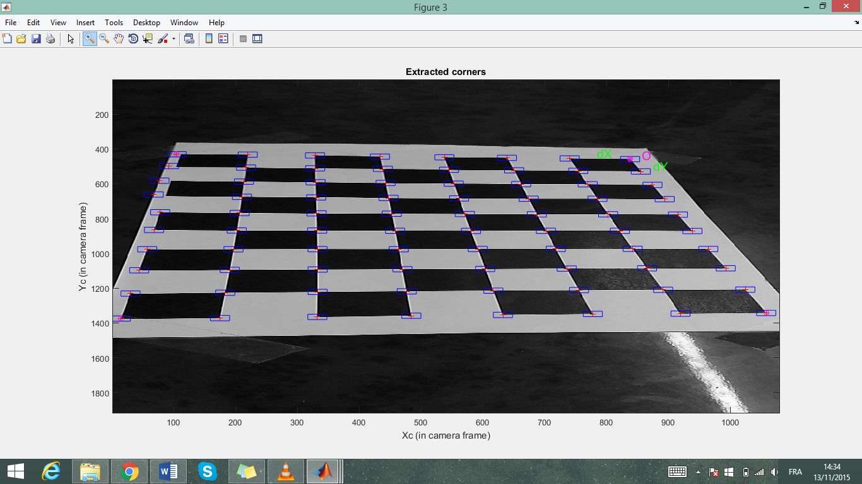

*(Extracted corner)*

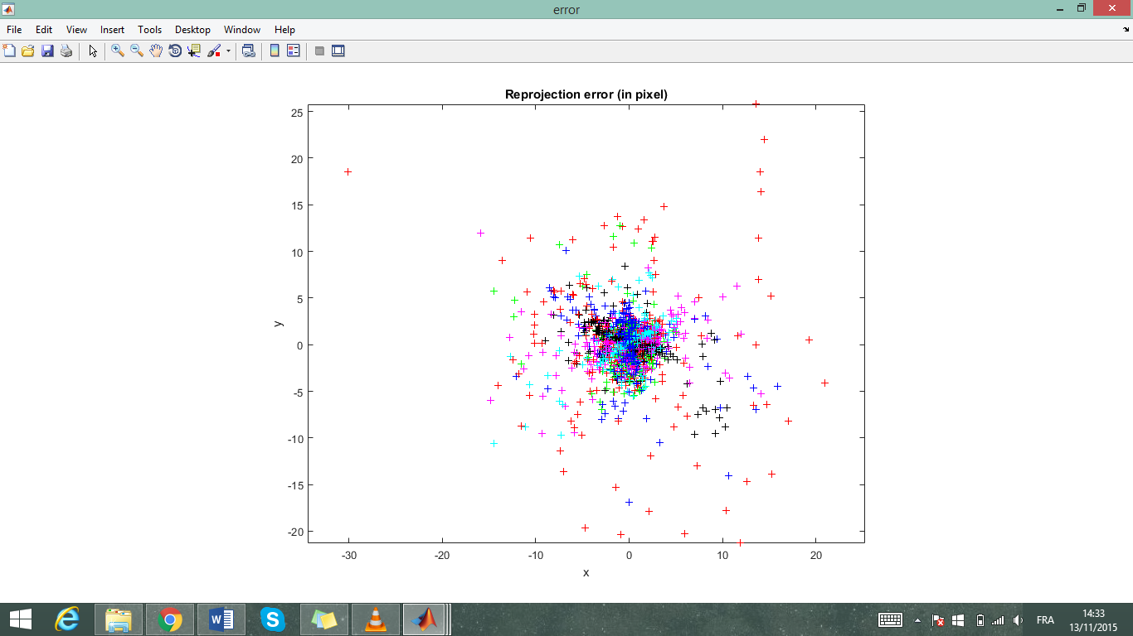

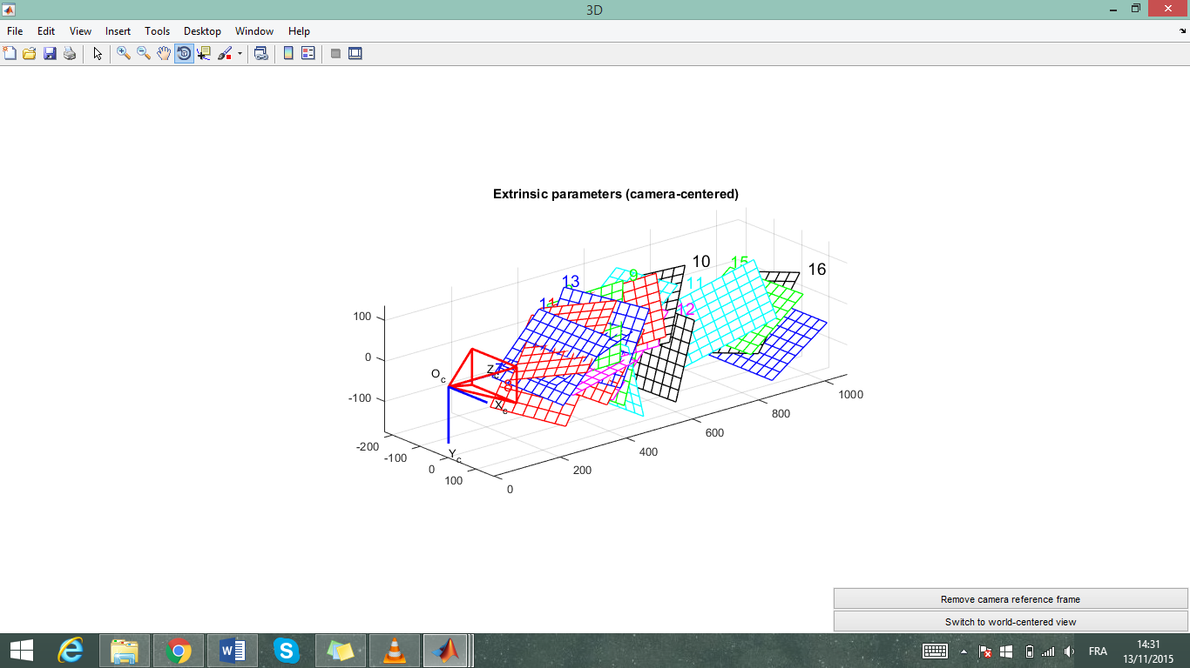

*(Extrinsic parameters)*

The extrinsic parameter are the relative positions of the grids with respect to the camera and then shoot positions.

## Description of the intrinsic parameters

The focal length is the distance from the lens of the camera to the object or the image (if there is at least two different lens).

The Principal point is the coordinates of the X and Y frames in the base image located inside the camera on the lens surface.

The skew is the angle variation between the X and Y axes of pixels in each picture. If the picture is tilted or bended, this is then different than 90°.

The distortion is the variation of depth of the object in a 3D space. It is a coefficient that relies the distortion effect on our image. When it is not equal to zero, it means that the lines are not perpendicular on the picture. Then the camera electronic cells are not orthogonal.

# Bibliography

* Bosch packaging technology :

<http://www.boschpackaging.com/en/pa/products/industries/technology/tg/pick-and-place-robotics-14030.php?ind=1678&tg=17538>

* Track and trace video concept :

<https://www.youtube.com/watch?v=Y94NcGrpS1A>

* Single Camera calibration ressources :

<http://www.mathworks.com/help/vision/camera-calibration.html?searchHighlight=image%20calibration>

<http://www.mathworks.com/help/vision/ug/single-camera-calibration.html>

<http://www.vision.caltech.edu/bouguetj/calib_doc/htmls/example.html>

<https://www.youtube.com/watch?v=zANHVzZeaYY>